Exp No : 9
ULTRASONIC SENSOR IN PROTEUS USING ARDUINO
AIM :
Towrite an Embedded C Program for interfacing Ultrasonic Sensor using Arduino Uno and Proteus
SOFTWARE REQUIRED :
- Proteus 8 software
- Arduino IDE software
PROGRAM :
int trig = 10;
int echo = 9;
long duration;
int cm;
void setup()
{
pinMode(trig, OUTPUT);
pinMode(echo, INPUT);
Serial.begin(9600);
}
void loop()
{
// Send ultrasonic pulse
digitalWrite(trig, LOW);
delayMicroseconds(10);
digitalWrite(trig, HIGH);
delayMicroseconds(10);
digitalWrite(trig, LOW);
// Read echo
duration = pulseIn(echo, HIGH);
// Calculate distance in cm
cm = (duration / 2) * 0.034;
// Print distance
Serial.print("Distance = ");
Serial.print(cm);
Serial.println(" cm");
delay(500);
}
CIRCUIT DIAGRAM :
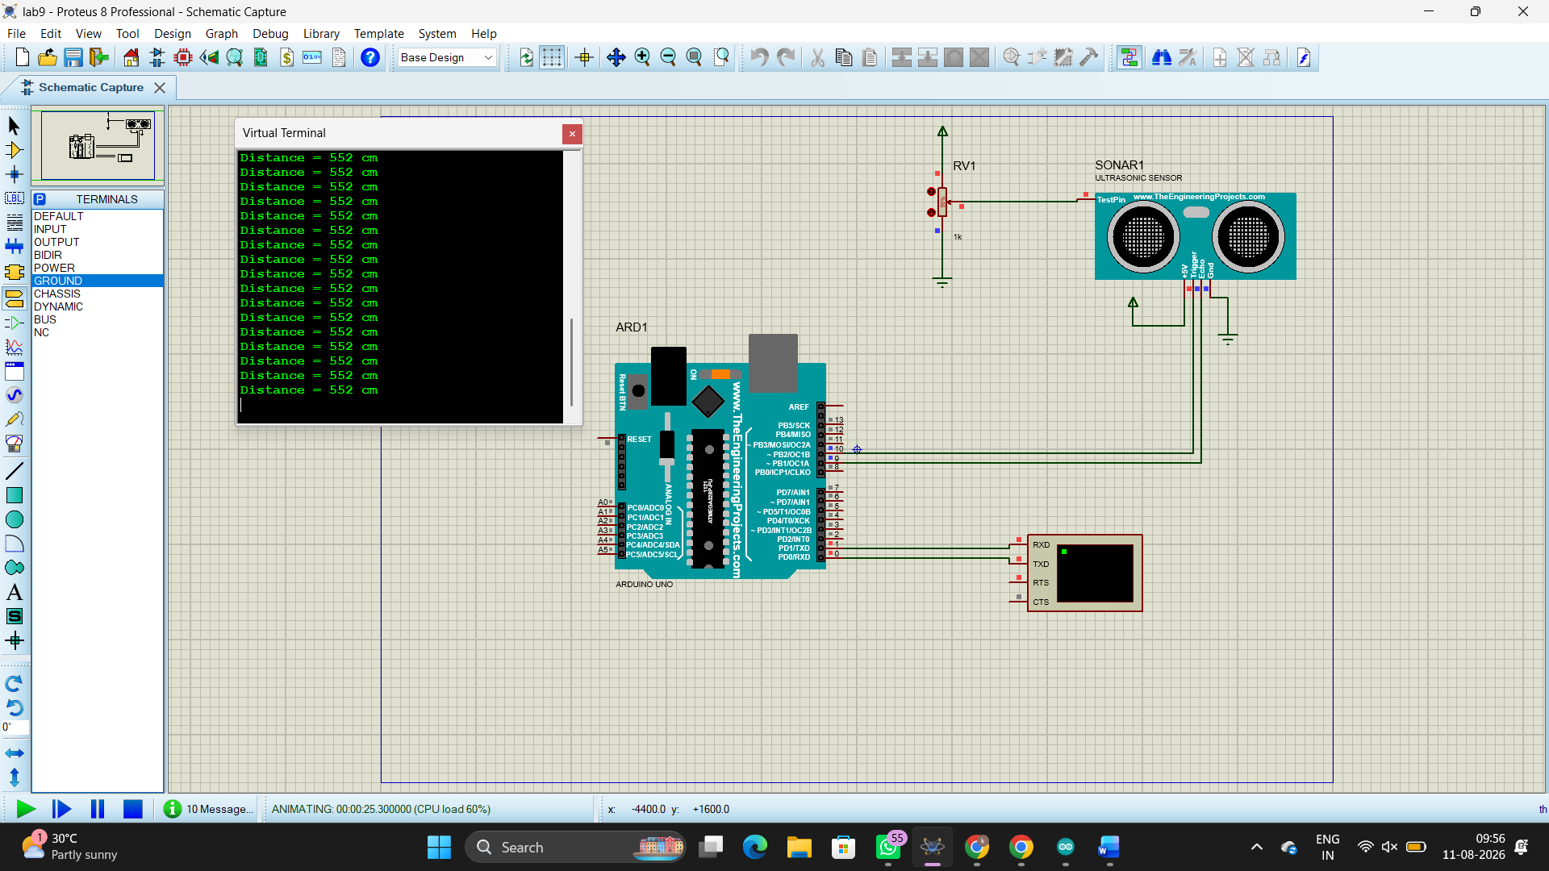
RESULT :
Thus the program has been successfully verified and executed.

